**Hello Team!** **Consider the below two tables**:

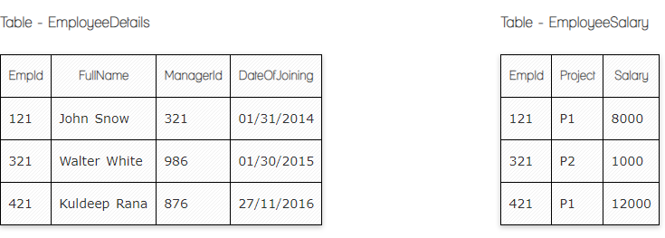

**Ques.1. Write a SQL query to fetch the count of employees working in project 'P1'.**

**Your Answer:**

*SELECT COUNT (*)*

*FROM EmployeeSalary*

*WHERE Project=’P1’*

**Ques.2. Write a SQL query to fetch employee names having salary greater than or equal to 5000 and less than or equal 10000.**

**Your Answer:**

*SELECT EmployeeDetails.FullName*

*FROM EmployeeDetails*

*INNER JOIN EmployeeSalary*

*ON EmployeeDetails.EmpID= EmployeeSalary. EmpID*

*WHERE EmployeeSalary.Salary BETWEEN 5000 AND 10000*

**Ques.3. Write a SQL query to fetch count of employees sorted by project's count in descending order.**

**Your Answer:**

*SELECT COUNT (EmpId), Project*

*FROM EmployeeSalary*

*GROUP BY Project*

*ORDER BY COUNT (EmpId) DESC*

**correct**

**Ques.4. Write a query to fetch employee names and salary records. Return employee details even if the salary record is not present for the employee.**

**Your Answer:**

*SELECT EmployeeDetails.FullName, EmployeeSalary.Salary*

*FROM EmployeeDetails*

*LEFT JOIN EmployeeSalary*

*ON EmployeeDetails.EmpID= EmployeeSalary.EmpID*

**correct**

**Ques.5. Write a SQL query to create an empty table with ‘Test’ name.**

**Your Answer:**

*CREATE TABLE Test(ID int, FirstName varchar(25), LastName varchar(35))*

**correct**

**Ques.6. Write a SQL query to delete an empty table with ‘Test’ name.**

**Your Answer:**

*DROP TABLE Test*

**Ques.7. Write a SQL query to fetch all the Employees details from EmployeeDetails table who joined in Year 2016.**

**Your Answer:**

*SELECT \**

*FROM EmployeeDetails*

*WHERE DateOfJoining) BETWEEN '01/01/2016' AND '31-12-2016'*

**Ques.8. Write a SQL query to insert new record to the EmployeeDetails table with any data.**

**Your Answer:**

*INSERT INTO EmployeeDetails(FullName, ManagerID, DateOfJoining)*

*VALUES(’Jhon Davit’, 987, ’02/02/2022’ )*

**Ques.9. Write a SQL query to update EmployeeSalery table with setting Salary to 2000 for Project P2.**

**Your Answer:**

*UPDATE EmployeeSalery*

*ET Salary=’2000’*

*WHERE Project=’P2’*

**Ques.10. Write a SQL query to right join both tables and draw the results.**

**Your Answer:**

*SELECT EmployeeDetails.EmpID,*

*EmployeeDetails.FullName,*

*EmployeeDetails.ManagerID,*

*EmployeeDetails.DateOfJoining,*

*EmployeeSalery.Project,*

*EmployeeSalery.Salary*

*FROM EmployeeDetails*

*RIGHT JOIN EmployeeSalary*

*ON EmployeeDetails.EmpID= EmployeeSalary.EmpID*

|  |  |  |  |  |  |
| --- | --- | --- | --- | --- | --- |
| *EmpID* | *FullName* | *ManagerID* | *DateOfJoining* | *Project* | *Salary* |
| *121* | *John Snow* | *321* | *01/31/2014* | *P1* | *8000* |
| *321* | *Walter White* | *986* | *01/30/2015* | *P2* | *1000* |
| *421* | *Kuldeep Rana* | *876* | *27/11/2016* | *P1* | *12000* |

**Now take these two tables:**

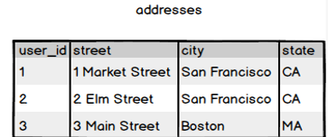

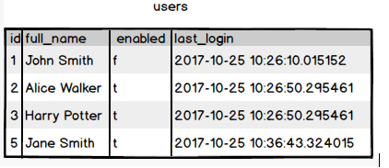

**Ques.11. Write a SQL query to fetch all users full_name from San Francisco.**

**Your Answer:**

*SELECT addresses.city, users.full_name*

*FROM addresses*

*INNER JOIN users*

*ON addresses.user_id=users.id*

*GROUP BY users.full_name*

*HAVING addresses.city=’San Francisco’*

**Ques.12. Write a SQL query to fetch all users full_name, last_login who are enabled**

**Your Answer:**

*SELECT users.full_name, users.last_login*

*FROM users*

*WHERE enabled = 't'*

**Ques.13. Write a SQL query to fetch all users full_name who are not from Main street**

**Your Answer:**

*SELECT addresses.street, users.full_name*

*FROM addresses*

*INNER JOIN users*

*ON addresses.user_id=users.id*

*GROUP BY users.full_name*

*HAVING addresses.street NOT LIKE ’Main Street’*

**Ques.14. Write a SQL query to fetch all users full_name who are from Main street or San Francisco**

**Your Answer:**

*SELECT addresses.street, addresses.city, users.full_name*

*FROM addresses*

*INNER JOIN users*

*ON addresses.user_id=users.id*

*WHERE addresses.street=’Main Street’ OR addresses.city=’San Francisco’*

**Ques.15. Write a SQL query to fetch user full_name who is equal to user_id from Boston (find user_id value in sub_query)**

**Your Answer:**

*SELECT full_name*

*FROM users*

*WHERE id=*

*(SELECT user_id*

*FROM addresses*

*WHERE city=’Boston’)*